

**INFORMATION INSTITUTE OF TECHNOLOGY**

In collaboration with

**UNIVERSITY OF WESTMINSTER**

**Software Development Group Project**

5COSC021C

Module Leader: Mr. Banuka Athuraliya

**Interview Suite**

CS - 75

Mentor: Mentor: Mrs. Vinodani Thilakarathne

|  |  |
| --- | --- |
| Name | Tharindu Madushanka |
| UOW Number | w2052209 |
| IIT Number | 20232113 |
| Group Number | CS 75 |

## 

## Abstract

The interview Suite project is designed to address the gap between the employers and employees by providing an intelligent solution for interview practice. Specifically, this platform uses natural language processing, body language analysis and real time feedback to motivate and support candidates through a realistic mock interview.

This report describes the process of development such as stakeholder identification, requirements gathering, AI transparency and ethical issues are solved thus keeping the convenience of the users and security at heart. The Interview Suit project is designed to follow the best practices of the industry and build a layered architecture to provide users with a reliable and efficient tool that will meet the needs of both job seekers and employers.

## 

## 

## 

## Acknowledgment

I would like to thank our module leader Mr. Banuka Athuraliya and our mentor Mr. Lakshan for guiding me to the course of this assignment. They were there to help me every step of the way, and her motivation is what helped me to complete this assignment successfully. I would like to thank all the lecturers who helped me by providing the necessary knowledge, without which I would not have been able to work effectively on this assignment.

Table of Contents

List of figures v

List of tables vi

**Chapter 4: System Requirements Specification (SRS)** 1

**4.1 Chapter Overview** 1

**4.2. Stakeholder Analysis** 1

**4.2.1. Onion Model** 1

**4.2.2. Stakeholder Descriptions** 2

**4.3. Selection of Requirement Elicitation Techniques/Methods** 4

**4.4. Discussion/ Analysis of Results** 5

**4.4.1 Survey Design** 5

**4.4.2 Analysis of Results** 9

**4.5. Use Case Diagram** 17

**4.6. Use Case Descriptions** 18

**4.7. Functional Requirements** 47

**4.8. Non-Functional Requirements** 48

**4.9. Chapter Summary** 49

**Chapter 5: Social, Legal, Ethical and Professional Issues** 50

**5.1. Chapter Overview** 50

**5.2 Dataset Ethical Clearance** 50

**5.3 SLEP Issues and Mitigation** 50

**5.4 Chapter Summary** 52

**Chapter 6: System Architecture & Design** 53

**6.1. Chapter Overview** 53

**6.2. System Architecture Design** 53

**6.2.1 Microservice Architecture** 56

**6.3. System Design** 58

**6.3.1. Class Diagram/Data Flow Diagram (DFD)** 58

**6.3.2. Sequence Diagram** 59

**6.3.3.UI Design and mockups** 60

**6.3.4. Activity Diagram** 61

References I

Appendix II

# List of figures

Figure 1: Onion Model 1

Figure 2: Use Case Diagram 17

Figure 3: Layered Architecture Example 53

Figure 4: Microservice Architecture 56

Figure 5: Layered architecture diagram for the Interview Suit App 57

Figure 6: Class Diagram for The Interview Suit 58

Figure 7: Sequence Diagram of Interview Suit 59

Figure 8: Activity Diagram 61

Figure 9: Home Page UI II

Figure 10: Login Page UI III

Figure 11: Signup Form UI III

Figure 12: User Profile Section UI III

Figure 13: Sample Interview Session UI IV

Figure 14: Team Member Section UI V

# List of tables

Table 1:Stakeholder Descriptions 4

Table 2:Survey Design 8

Table 3: Analysis of Survey Results 16

Table 4:Use Case Description for usecase ID1 19

Table 5:Use Case Description for usecase ID2 20

Table 6:Use Case Description for usecase ID3 22

Table 7: Use Case Description for usecase ID4 24

Table 8: Use Case Description for usecase ID5 26

Table 9: Use Case Description for usecase ID6 28

Table 10:Use Case Description for usecase ID7 30

Table 11: Use Case Description for usecase ID8 32

Table 12: Use Case Description for usecase ID9 34

Table 13: Use Case Description for usecase ID10 36

Table 14:Use Case Description for usecase ID11 38

Table 15:Use Case Description for usecase ID12 40

Table 16: Use Case Description for usecase ID13 42

Table 17:Use Case Description for usecase ID14 44

Table 18: Use Case Description for usecase ID15 46

Table 19:Functional Requirements 48

Table 20: Nonfunctional requirements 49

# **Chapter 4: System Requirements Specification (SRS)**

## **4.1 Chapter Overview**

In this section describe all the system requirements in the Interview Suit system. This chapter will guide you to get fully understanding about Stakeholder Analysis, Selection of Requirement Elicitation Techniques/Methods, Discussion/ Analysis of Results, Use Case Diagrams, Use Case Descriptions, Functional Requirements (with prioritization), Non-Functional Requirements and finally Chapter Summary. This Chapter will provide all the environment about the Interview Suit System.

## **4.2. Stakeholder Analysis**

To be successful on any project there should need understanding and interest of the many stakeholders who influence and gain benefit from the project. Also Interview Suit AI powered platforms success depends on that understanding of stakeholders. The main stakeholders and their primary requirements are categorized in this study.

### **4.2.1. Onion Model**

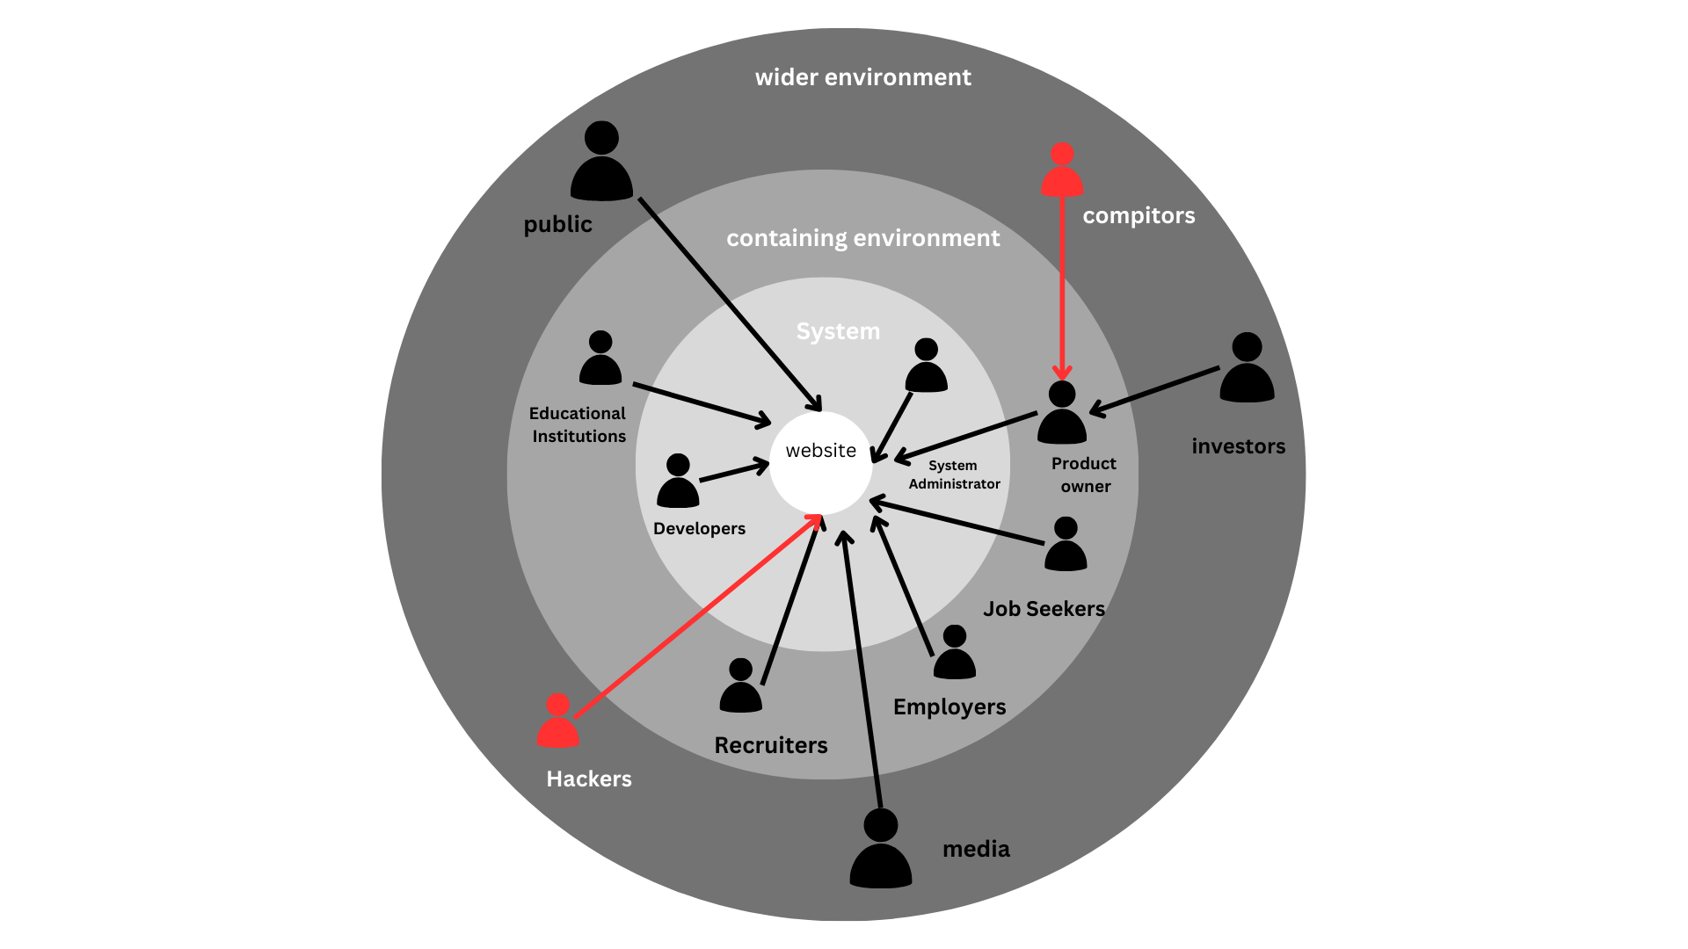

Figure : Onion Model

### **4.2.2. Stakeholder Descriptions**

|  |  |
| --- | --- |
| **Stakeholders** | **Viewpoint** |
| Functional beneficiary | |
|
| Job Seekers | The first and direct consumers of the platform who use the interview preparation tools to improve their ability and preparedness for job interviews. |
| Financial beneficiary | |
|
| Product Owner | Beneficial owner of the platform gains possible income from employers making subscriptions for more upgrades. |
| Investors | Fund the project and may seek to recover their investment through revenue generating models such as paid services to employers. |
| Educational Institutions | May use the platform to teach students especially in interview and other soft skills thus benefiting the larger community in that there will be enhanced job market preparedness. |
| HR teams of companies |  |
| Social beneficiary | |
|
| Public | Beneficially affected by the aspect of the platform as a contribution to preparation of workforce and to the economy as more candidates are prepared for employment. |
| Operational beneficiary | |
|
| Recruiters | They need to use the platform to identify and evaluate potential candidates for hire to improve their efficiency and select more appropriate candidates. |
| System Administrator | Overseas the technical running of the platform, making sure that it is up and running regularly, secure and performs optimally to enhance the user experience. |
| Negative Stakeholders | |
|
| Competitors | Other platforms may get the feeling that they are competing against a special system that is bringing something different and could feel threatened. |
| Hackers | Present threats to the system security should be closely watched because they may misuse user information or tamper with the platform. |
| Regulatory | |
|
| System Containing Environment | Leading on compliance issues such as data protection and privacy legally, to check that the platform compiles with the legal provisions. |
| Experts | |
|
| Media | Credibility to the platform to influence adoption rates and public opinion could be granted by providing it recognition. |
| Educational Institutes | This data will help to inform knowledge about the effectiveness of interview preparation resources for the platform's instructional approaches. |
| Neighboring systems | |
|
| Cloud Storage Providers | Effectively and securely store audio recording, responses data and other user generated content |

Table :Stakeholder Descriptions

## **4.3. Selection of Requirement Elicitation Techniques/Methods**

Each stakeholder should have a comprehensive understanding of each other. To ensure that various requirement elicitation techniques were selected. These techniques are chosen to gather specific needs from

secondary stakeholders like recruiters and education; institutions as well as main users like employers and job seekers. The selected methods are of:

* Interviews

Conducted with prospective users such as recruiters, employers and job seekers to learn more about their requirements, difficulties and platform expectations. Open end, in-depth interview facilitates the sharing of specific requirements by stakeholders and offers qualitative information that is crucial for comprehending complicated demands.

* Questionnaires and Surveys

Distributed to a larger audience, comprising job seekers and employers in order to gather quantitative data on certain aspects such the need for gamified interview practice, the interest in AI driven feedback and the preferred evaluation tools. Standardized responses from a large group may be efficiently gathered via questionnaires which facilitate the identification of shared criteria and the prioritization of characteristics according to response frequency.

* Document Analysis

Competition platforms industry information and current job preparation tools sp identify features that are useful for users and efficient. Due to the analysis of documents that contain information about the industry and its trends the team can create a competitive and relevant platform.

* Observational Studies

Watching practice interviews or fake interviews to know what common issues a job seeker faces and where AI assistance could be helpful.

* Brainstorming

The target team members and stakeholders were involved in brainstorming sessions to give ideas and identify potential requirements for the interview Suite. People were free to share what they would like to see added to the platform, what they do not like about how the platform is currently used for interview preparation and how the platform can be made unique.

## **4.4. Discussion/ Analysis of Results**

### **4.4.1 Survey Design**

|  |  |
| --- | --- |
| **Goal of the question** | **Question** |
| This question seeks to know how much the respondent is aware of the use of AI in either recruitment process or interview session. This information may be used by the team to determine the extent of the user experience with similar technologies in order to decide how much direction or introduction material need to be added in this platform. |  |
| To determine whether or not a user-friendly design and potential onboarding features are required by assessing the user’s level of technology literacy during the hiring or job seeking process. |  |
| To know the respondent’s position so as to provide specific information on the needs of each group in relation to the platform. |  |
| To identify common challenges that candidates face during interview preparation in order to help with the prioritization of features such as realistic interview simulation, feedback mechanism and confidence boosting tools. |  |
| To assess the level of demand for interview feedback through an AI based tool that helps in estimating the potential user adoption and thus the order of preference for developing features that are feedback oriented. |  |
| To determine which of the features are most appreciated by users in an interview preparation tool in order to help the team decide what features to focus on. |  |
| To evaluate the level of comfort of the users through the body language and facial expressions and decide whether this feature would be welcomed by the users or not whether due to some privacy issues it could be avoided. |  |
| To assess how much users value feedback for soft skills in addition to technical skills to enable the team to determine the need for feedback in the tool to be well rounded. |  |
| To determine which devices the users are most likely to use in order to make the platform more accessible and responsive to the right device. |  |
| To identify the issue that employers encounter in the first stage of the interview process so that the team could further enhance the platform’s functionality to improve the process of candidates filtering and assessments. |  |
| To determine the level of interest in an AI platform that would automatically shortlist candidates and conduct assessments to determine the level of interest for the kind of functionality that would enhance the efficiency of the hiring process in the team. |  |
| To determine which features are most valuable to employers in a candidate screening tool, to inform feature selection to best serve user needs in evaluating and selecting candidates. |  |
| To identify employers’ readiness to use AI based body language and facial expressions recognition for candidate assessment to evaluate the acceptability and possible effect of this feature in the toll. |  |
| To assess how much employers care about the progress of a candidate over time and thus help the team appreciate the value of progress tracking for long term candidate assessments. |  |
| To determine the employer’s readiness to use the platform for recruitment which will allow the team to evaluate the level of market demand and possible levels of businesses adoption of the platform. |  |
| That can be used to measure people’s willingness to use the platform to pay, thereby enabling a decision on whether there can be an implementation of the subscription model and how much to change for the platform. |  |
| To gather feedback as to which new features users would like incorporated into the system to make recommendations for improvement of the system consistent with anticipated user demand and expectation. |  |
| To know what users, have to worry about in the context of interview and recruitment, so that the team can work on possible problems such as privacy, accuracy, bias and the human aspect in the tool. |  |

Table :Survey Design

### **4.4.2 Analysis of Results**

|  |  |
| --- | --- |
| **Question 1** | |
| Result | **Forms response chart. Question title: Have you ever used an AI-powered platform for interview preparation or recruitment?. Number of responses: 28 responses.** |
| Analysis | The survey reveals the 64.3% of the participants have no knowledge about the AI Interview platform and there should be awareness, simplicity and assurance of accuracy and privacy to enhance the use. |
| **Question 2** | |
| Results | **Forms response chart. Question title:   How comfortable are you with using technology for job preparation or hiring processes?  . Number of responses: 28 responses.** |
| Analysis | The majority of respondents, or 42.9% do not have an issue with technology for job preparation and should not object to an AI Interview interface. Only 3.8% of the participants reported low comfort, which presents the potential of using the platform users. |
| **Question 3** | |
| Results | **Forms response chart. Question title: What is your primary role ?. Number of responses: 28 responses.** |
| Analysis | According to the survey, 92.9% of the respondents are either job seekers or undergraduates and only 7.1% are recruiters. |
| **Question 4** | |
| Results | **Forms response chart. Question title:   What challenges do you face in preparing for job interviews? (Select all that apply)  . Number of responses: 26 responses.** |
| Analysis | The two main concerns are lack of questions during an interview and communication. This shows the need of a website with sample questions, feedback and techniques on communications. |
| **Question 5** | |
| Results | **Forms response chart. Question title: How likely  are you to use an AI platform provides feed back on your interview skills? (eg- confidence, communication, body language). Number of responses: 26 responses.** |
| Analysis | In total 96.2 % of the respondents have indicated their willingness to use an AI driven platform for interview feedback which means that potential users interested in the feature devoted to confidence, communication and body language are rather high. |
| **Question 6** | |
| Result | **Forms response chart. Question title: Which feature would be most valuable to you in an interview preparation tool?. Number of responses: 26 responses.** |
| Analysis | The three features that are the most appreciated are mock interview practice, role specific assessment and dynamic question generation. This underlines how candidates appreciate communication, individualization and activity of the tools used during the interview preparation. |
| **Question 7** | |
| Result | **Forms response chart. Question title: Would you be comfortable with the platform analyzing your body language and facial expressions to provide feedback?. Number of responses: 26 responses.** |
| Analysis | The respondents are also comfortable with the platform interpreting their body language and facial expressions for feedback with 84.6% acceptance level. |
| **Question 8** | |
| Result | **Forms response chart. Question title: How important is it to receive feedback on soft skills (e.g., communication, confidence) in addition to technical skills?. Number of responses: 26 responses.** |
| Analysis | As it is illustrated in the figure above, a vast majority 80.8% consider feedback on soft skills to be very important. This shows that the users want feedback that encompasses all aspects of the interview preparation including the soft skills. |
| **Question 9** | |
| Result | **Forms response chart. Question title:   What devices would you likely use to access this platform? (Select all that apply)  . Number of responses: 26 responses.** |
| Analysis | Regarding the Result a desktop or laptop is the most used device by the users which 92.3% hence the platform should be designed for large screen and can be optimized for smartphone and tablets second preference. |
| **Question 10** | |
| Result | **Forms response chart. Question title: What challenges do you face in screening candidates during the initial interview rounds? (Select all that apply) . Number of responses: 2 responses.** |
| Analysis | The main problem is the assessment of soft skills of the candidates, which is stated by all the respondents, 100% of the respondents, which confirms the need for tools for the assessment of the soft skills of the candidates. |
| **Question 11** | |
| Result | **Forms response chart. Question title: How helpful would it be to have an AI platform that could shortlist candidates based on interview performance and provide initial assessments? . Number of responses: 2 responses.** |
| Analysis | All the respondents express a high interest in automation tools in the recruitment process and find the idea of an AI platform that can assist shortlisting and initial candidate review useful. |
| **Question 12** | |
| Result | **Forms response chart. Question title: Which features would you find most useful in a candidate screening tool?. Number of responses: 2 responses.** |
| Analysis | The most valuable feature of the tool is described as role-specific question generation. The second most useful is the automatic soft skills assessment with the score-based ranking as well. This implies that their engagement preference has more leaning towards the areas of customized techniques of questioning and tools for efficient evaluation and short listing of the candidates. |
| **Question 13** | |
| Result | **Forms response chart. Question title: Would you be comfortable with an AI tool analyzing a candidate's body language and facial expressions to provide feedback and scores?. Number of responses: 2 responses.** |
| Analysis | There is an equal percentage between comfortable with AI tool and maybe. |
| **Question 14** | |
| Result | **Forms response chart. Question title: How important is it to see a candidate’s improvement over time (e.g., through repeated interviews or skill assessments)?. Number of responses: 2 responses.** |
| **Question 15** | |
| Result | **Forms response chart. Question title: Would you consider using this platform for your company’s recruitment process?. Number of responses: 2 responses.** |
| **Question 16** | |
| Result | **Forms response chart. Question title: How likely are you to pay for a subscription to use this platform?. Number of responses: 28 responses.** |
| **Question 17** | |
| Result |  |
| **Question 18** | |
| Result | **Forms response chart. Question title: Do you have any concerns about using AI in interview preparation or recruitment? (Select all that apply). Number of responses: 28 responses.** |
| **Question 19** | |
| Result |  |

Table : Analysis of Survey Results

## **4.5. Use Case Diagram**

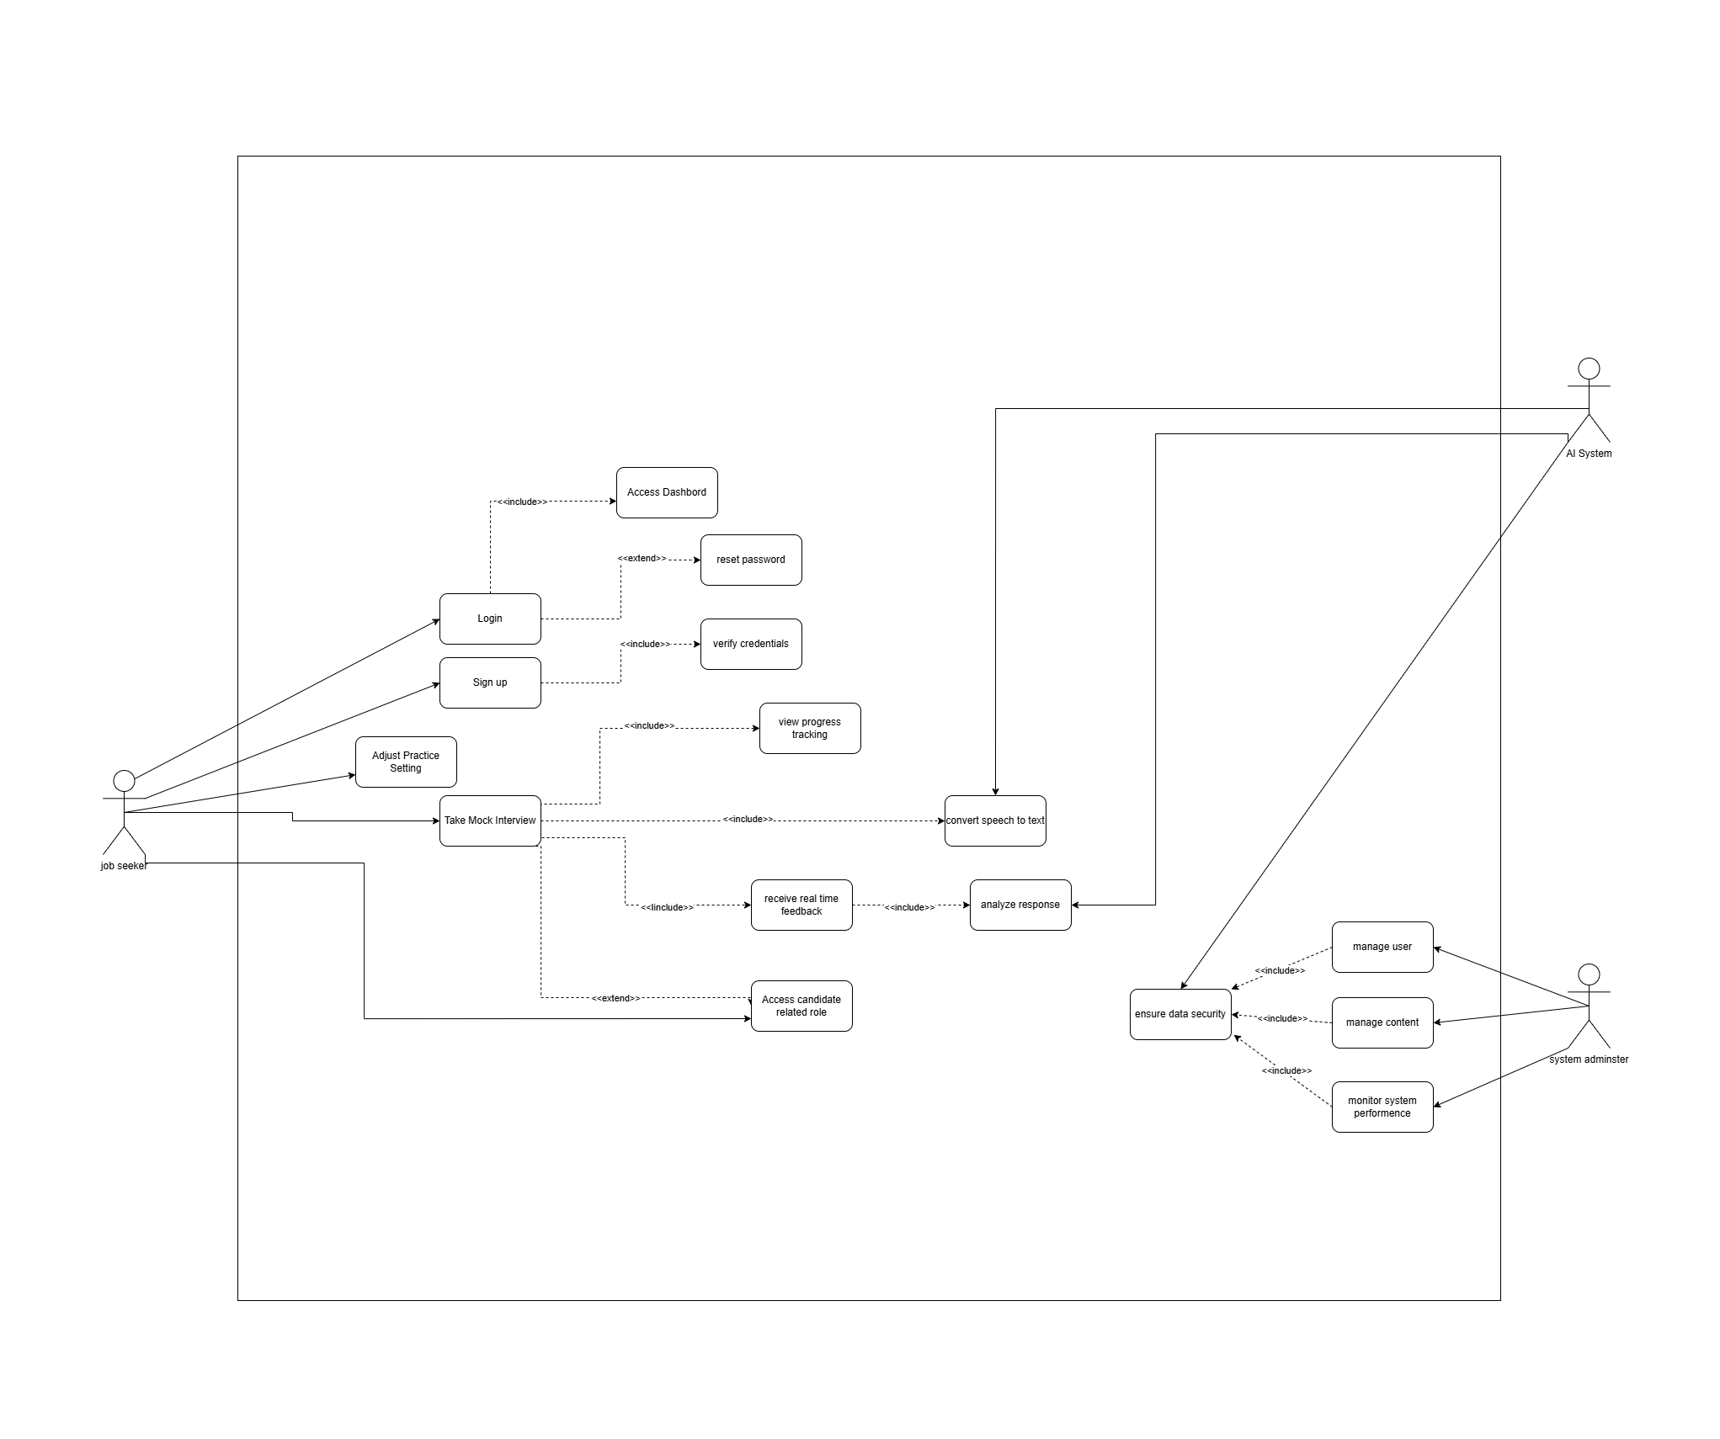

Figure : Use Case Diagram

## **4.6. Use Case Descriptions**

|  |  |  |
| --- | --- | --- |
| **Use Case Name** | Login | |
| **Use Case ID** | UC-001 | |
| **Description** | Enable clients (candidates, employers) to safely sign in to the Service or the application. | |
| **Priority** | High | |
| **Primary Actor** | User (Job seekers, Employers) | |
| **Supporting Actors** | None | |
| **Pre-Conditions** | User must have registered with the platform and must enter the correct username and password | |
| **Trigger** | Users navigate into the homepage and choose the login into account selection to enter their username and password. | |
| **Main flow** | **Actors** | **System** |
| 1.Users enter correct credentials  2.Users click the “Login” button | 1. System validate user credentials  2. System gives access after successfully logging to redirect their dashboard. |
| **Exception flow** | **Actors** | **System** |
| 1. User entered incorrect credentials |  |
| **Alternate flow** | **Actors** | **System** |
| User click on “Forgot password” button |  |
| **Exclusions** | System sends a reset link of the password to the mail address that the user has provided during the course of registration. | |
| **Post Conditions** | Users are logged into the system and are able to view their homepage/ dashboard. | |

Table :Use Case Description for usecase ID1

|  |  |  |
| --- | --- | --- |
| **Use Case Name** | Sign up | |
| **Use Case ID** | UC-002 | |
| **Description** | Enables create a new account for the new users (Job Seekers, Employers) on the platform | |
| **Priority** | High | |
| **Primary Actor** | User (Job seekers, Employers) | |
| **Supporting Actors** | None | |
| **Pre-Conditions** | Users should have one existing account on the application | |
| **Trigger** | Users navigate into signup form with registration process | |
| **Main flow** | Actors | System |
| 1. Users fill the signup form with correct information’s  2. After fill the form click sign up button | 1. Provide information that is verified by the system.  2. Generates a new user account and sends an email to the new user |
| **Exception flow** | Actors | System |
| If user enter invalid information’s like already in use emails or duplicate information | Gives an error message to the user to enter the correct information. |
| **Alternate flow** | Actors | System |
| Can add optional profile details like role type and any other information | Save user provide additional information |
| **Exclusions** | User deletion and account validation | |
| **Post Conditions** | User account is created, and the user is redirected to the login page or the onboarding page. | |

Table :Use Case Description for usecase ID2

|  |  |  |
| --- | --- | --- |
| **Use Case Name** | Adjust Practice Settings | |
| **Use Case ID** | UC-003 | |
| **Description** | Enable candidates to adjust on the conditions of their mock interview practice sessions for example the level of difficulty, the type of questions asked and kind of feedback. | |
| **Priority** | Medium | |
| **Primary Actor** | Job Seekers | |
| **Supporting Actors** | None | |
| **Pre-Conditions** | User (Jobseeker) must have an account and logged in to the system | |
| **Trigger** | Job Seeker enters the practice settings page and chooses options for mock interview environments. | |
| **Main flow** | Actors | System |
| 1. Job Seekers chosen preferences for practice questions in various levels  2. Click the save button to update change settings | 1. The system shows the options that can be customized  2. System store the job seeker’s preferences and uses them in subsequent practice sessions |
| **Exception flow** | Actors | System |
| Try to apply invalid settings (no options are chosen) | Provide an error message to the job seekers to make some changes to the selection made. |
| **Alternate flow** | Actors | System |
| Job Seekers choose general options instead of specific ones. | System sets default values to the practice sessions |
| **Exclusions** | Modifications of the fundamental system parameters, account specific options | |
| **Post Conditions** | Job seekers settings are saved and the further practice sessions reset based on these settings. | |

Table :Use Case Description for usecase ID3

|  |  |  |
| --- | --- | --- |
| **Use Case Name** | Take Mock Interview | |
| **Use Case ID** | UC-004 | |
| **Description** | Offers the job application the chance to participate in mock interview exercises that can be assessed in terms of body language, response and other aspects of performance. It allows the job applicant to participate in a mock interview simulation that can be assessed in terms of body language, response and other aspects of performance. | |
| **Priority** | High | |
| **Primary Actor** | Job Seekers | |
| **Supporting Actors** | AI System | |
| **Pre-Conditions** | The job seekers require a web camera and microphone and should be online. The specific interview settings should be default or as set by the employer. The job seeker should have a webcam and a microphone and must be online. What needs to be set to default values, or the present frequency should be used for the interview, | |
| **Trigger** | Job seekers start a mock interview session either from their control panel or practice page. | |
| **Main flow** | Actors | System |
| 1. Job seekers begin the exercise of mimicking a real interview.  2. Job seekers answer all the questions that the AI system poses to the job seekers. | 1. In this case the system starts a mock interview in which it presents questions according to the job seekers’ preferences.  2. Responses are stored and rates of success in terms of confidence and body language are assessed.  3. System terminates the last session and gets ready to provide feedback. |
| **Exception flow** | Actors | System |
| Job seekers experience a technical hitch for instance the camera or microphone is not functioning properly. | System identifies technical problems on the computer, shows an error message or asks the user to undertake some corrective measures. |
| **Alternate flow** | Actors | System |
| Candidate takes a deserved break | System allows working with the current data set and with the possibility to resume the work from the previous page. |
| **Exclusions** | Live real time interview interaction with human interviewers’ external measures. | |
| **Post Conditions** | Mock interview sessions are as follows and the feedback given to the job seekers is as follows. | |

Table : Use Case Description for usecase ID4

|  |  |  |
| --- | --- | --- |
| **Use Case Name** | Access Candidate-Related Role | |
| **Use Case ID** | UC-005 | |
| **Description** | Enables the employer to review/ display candidate information and documents and features for narrowing the candidate search by role-based criteria. | |
| **Priority** | High | |
| **Primary Actor** | Employer | |
| **Supporting Actors** | AI System | |
| **Pre-Conditions** | Candidate profile must be visible only to the recruiter or employer who logged in and has access to the profiles. | |
| **Trigger** | Employers use the candidate management to view the specific profiles and details. | |
| **Main flow** | Actors | System |
| 1. Employer chooses a candidate related position or position description to examine.  2. Candidate’s profile, skills and qualification are accessible by the employer | 1. System allows to search the necessary candidate information such as qualification, experience and interview results  2. System has opinions to either shortlist or rate the candidate. |
| **Exception flow** | Actors | System |
| Employer tries to view a profile that is not allowed, or they not have permission to view it | System shows a message displaying that access is limited |
| **Alternate flow** | Actors | System |
| Employers narrow down the list of potential employees by certain standards. As a example by the level of experience | System filters the list and brings out a list of candidates that meet the set of requirements. |
| **Exclusions** | Hiring decisions made without intermediaries checks of candidate’s data with third parties | |
| **Post Conditions** | Candidate profile is successfully viewed by the employer and the latter has the possibility to add the candidate to the list of candidates for further considerations. | |

Table : Use Case Description for usecase ID5

|  |  |  |
| --- | --- | --- |
| **Use Case Name** | Receive Real-Time Feedback | |
| **Use Case ID** | UC-006 | |
| **Description** | Include mock interview feedback to the candidate in a simulated interview which involves ability to communicate confidence and nonverbal cues. | |
| **Priority** | High | |
| **Primary Actor** | Job Seeker | |
| **Supporting Actors** | AI System | |
| **Pre-Conditions** | Job seeker must be in a mock interview session and must have activated real time feedback in settings. | |
| **Trigger** | Job seekers start answering interview questions in mock interview sessions. | |
| **Main flow** | Actors | System |
| 1. Interviewee gives answers to interview questions.  2. Job seekers perceives feedback signs as they answer | 1. System responds to the participant’s answers in real time and tracks aspects such as the tone, eye contact and speaking rate.  2. System offers immediate feedback in terms of visual prompts or messages to the job seeker on what they need to do. |
| **Exception flow** | Actors | System |
| Job Seekers receives feedback late or not at all because of network or technical problems | System identifies problems and shows a message that there is limited feedback. |
| **Alternate flow** | Actors | System |
| Job seekers change the way of receiving feedback to the end of the session instead of the process. | Feedback store in a queue and only displayed at the end of the session |
| **Exclusions** | Summary of final feedback, manual feedback from human ratters | |
| **Post Conditions** | The session is ended with the guidance given during the interview so the job seeker can be corrected in the process. | |

Table : Use Case Description for usecase ID6

|  |  |  |
| --- | --- | --- |
| **Use Case Name** | Analyze Response | |
| **Use Case ID** | UC-007 | |
| **Description** | Allow the system to assess the job seeker's answers during a mock interview and assesses such as relevance, intonation, clarity and confidence to provide feedback. | |
| **Priority** | High | |
| **Primary Actor** | AI System | |
| **Supporting Actors** | Job Seekers | |
| **Pre-Conditions** | Job seekers must have completed at least one response during a mock interview session. | |
| **Trigger** | During a mock interview session, the job seekers give an answer to an interview question | |
| **Main flow** | Actors | System |
| Job seekers answer a question | 1. The system captures the job seeker’s response  2. System evaluate response in terms of tone, pacing, confidence and clarity of the response  3. System generates feedback depending on the analysis and saves it for immediate or cumulative feedback |
| **Exception flow** | Actors | System |
| Job seeker’s response is either missing or not audible to the interviewer. | System identifies a problem with the response and forces the job seekers to restate or elaborate on the response. |
| **Alternate flow** | Actors | System |
| A job seeker may request an analysis summary after responding to several questions. | System collects response data and provides a summary of analysis for the session. |
| **Exclusions** | Human driven analysis cross checking with data from other sources. | |
| **Post Conditions** | System provides detailed feedback for the job seekers and the areas that the job seeker needs to work on based on the analyzed response. | |

Table :Use Case Description for usecase ID7

|  |  |  |
| --- | --- | --- |
| **Use Case Name** | Convert Speech to Text | |
| **Use Case ID** | UC-008 | |
| **Description** | Convert the answer of the job seeker during a mock interview in order to analyze them with the help of the system. | |
| **Priority** | High | |
| **Primary Actor** | AI System | |
| **Supporting Actors** | Job Seeker | |
| **Pre-Conditions** | Job seekers' microphone is open, and they are in the mock interview sessions. | |
| **Trigger** | Job seekers start answering a sample a interview questions that has been posed to the candidate, | |
| **Main flow** | Actors | System |
| Job seeker gives an oral answer | 1. System records the voice of the job seeker.  2. System translates the actual response of the candidate into text from the speech that the candidate has given.  3. The text response is saved to the system for further analysis and generation of feedback. |
| **Exception flow** | Actors | System |
| Employment seekers' reply is ambiguous or insufficient. | System identifies problems with audio quality or lack of speech, in which case the job seekers are asked to repeat the response. |
| **Alternate flow** | Actors | System |
| Job seekers decide to type his response on the keyboard | Program records the types input rather than converting it into speech recognition |
| **Exclusions** | Interview transcription services, voice recognition beyond the interview | |
| **Post Conditions** | The response of the job seekers is converted to text and saved for further analysis to provide a comprehensive review of the response content and presentation. | |

Table : Use Case Description for usecase ID8

|  |  |  |
| --- | --- | --- |
| **Use Case Name** | View Progress Tracking | |
| **Use Case ID** | UC-009 | |
| **Description** | Enables applicants to monitor their performance of their previous | |
| **Priority** | Medium | |
| **Primary Actor** | Job Seeker | |
| **Supporting Actors** | AI System | |
| **Pre-Conditions** | Applicants must be signed in to their account and they have at least one mock interview completed. | |
| **Trigger** | Job seeker logs in to the system and goes to the performance history tab to monitor their progress. | |
| **Main flow** | Actors | System |
| 1. Job seekers choose the option of tracking the progress  2. Job seeker reflects on self-performance visualization such as scores, feedback summaries etc. | 1. System collects performance data from the previous mock interview sessions.  2. System uses graphs, charts and summaries to display progress made in each period. |
| **Exception flow** | Actors | System |
| Job seekers does not have any completed sessions to look at | System presents a message to the job seekers to do a mock interview session in order to produce progress data. |
| **Alternate flow** | Actors | System |
| Job seekers choose a particular session to receive precise feedback | System provides session related information such as areas to be developed and areas of competency. |
| **Exclusions** | Any other tools or performance tracking done outside the platform of the software. | |
| **Post Conditions** | Employment candidate gets feedback on the performance and finds more about strengths and weaknesses to motivate constant training. | |

Table : Use Case Description for usecase ID9

|  |  |  |
| --- | --- | --- |
| **Use Case Name** | Verify Credentials | |
| **Use Case ID** | UC-010 | |
| **Description** | Allows the system to verify user provided login credentials t ensure secure access to the platform | |
| **Priority** | High | |
| **Primary Actor** | System | |
| **Supporting Actors** | User (Job Seeker, Employer) | |
| **Pre-Conditions** | User must have an account with the website with proper credentials that is username and password | |
| **Trigger** | User enters his login details on the login page of the site. | |
| **Main flow** | Actors | System |
| Users provide their username and password and send the login form to the server | 1. System checks the databases and gets the entered username corresponding credentials.  2. While in the case of benign entered systems compare the entered password with the hashed password stored with the username.  3. In the case where the credentials value matched the system allowed access by the user |
| **Exception flow** | Actors | System |
| User enters wrong or invalid login details | System shows a message of login failure and then asks the user to try again. |
| **Alternate flow** | Actors | System |
| User clicks on the button that says, “Forgot Password”. | System allows the user to start the process of password reset by entering his/her email and receiving a reset link. |
| **Exclusions** | Any form of password reset, sign up, or second-factor authentication procedures. | |
| **Post Conditions** | The system verifies the identity of the user and if valid, the user is allowed to proceed, otherwise the system returns an appropriate message. | |

Table : Use Case Description for usecase ID10

|  |  |  |
| --- | --- | --- |
| **Use Case Name** | Reset Password | |
| **Use Case ID** | UC-011 | |
| **Description** | Enables users to regain control of forgotten passwords and update them when necessary due to security issues. | |
| **Priority** | High | |
| **Primary Actor** | User (Job Seeker, Employee) | |
| **Supporting Actors** | System | |
| **Pre-Conditions** | Users must have an account which is registered with the correct credentials. | |
| **Trigger** | Users click the “Forgot Password” option on the login page. | |
| **Main flow** | Actors | System |
| 1. User starts the password reset process by entering the registered email or password. | 1. System checks the authentication of the given email or phone number.  2. System forms a password reset link or code and delivers it to the user.  3. Users click the link or types the code to change their password  4. Server accepts the new password, and the change is made on the specific user's account. |
| **Exception flow** | Actors | System |
| User entered an unregistered email or phone number | System shows a message that the email or phone number does not belong to any account. |
| **Alternate flow** | Actors | System |
| User contacts support to get help in the password reset process. | The system has a feature of manual password reset through the administrator's intervention. |
| **Exclusions** | Being able to change passwords from the user dashboard. | |
| **Post Conditions** | Users are able to change their password, and they are able to sign with the new password. | |

Table :Use Case Description for usecase ID11

|  |  |  |
| --- | --- | --- |
| **Use Case Name** | Access Dashboard | |
| **Use Case ID** | UC-012 | |
| **Description** | Allow users to navigate to their home page once logged in where they can see some of the features and statistics that are of importance to them. | |
| **Priority** | High | |
| **Primary Actor** | User (Job Seeker, Employer) | |
| **Supporting Actors** | System | |
| **Pre-Conditions** | User must log their account | |
| **Trigger** | User logged in and navigate into their personal dashboard | |
| **Main flow** | Actors | System |
| 1. User logs into the platform  2. Users interact with the application by moving through the dashboard to reach the feature or data relevant to the role. | 1. System checks the authentication of the user.  2. System retrieves and displays content depending on the user type for example, progress bar for the job seeker, candidate list for the recruiter or report for the employer. |
| **Exception flow** | Actors | System |
| 1. User encounters a technical issue while accessing the dashboard | System can identify the problem and give an error message with a retry button. |
| **Alternate flow** | Actors | System |
| User can change their layout of the dashboard to make some features more noticeable or less noticeable | System stores the layout of the custom dashboard and then restores the interface to that layout. |
| **Exclusions** | Getting hold of analytics features or administrative options that the user does not need. | |
| **Post Conditions** | Users can navigate to their dashboard and manipulate the features or data relevant to their position. | |

Table :Use Case Description for usecase ID12

|  |  |  |
| --- | --- | --- |
| **Use Case Name** | Manage User | |
| **Use Case ID** | UC-013 | |
| **Description** | Enables the system administrator to create, modify, deactivate or even delete users and their roles. | |
| **Priority** | High | |
| **Primary Actor** | System Administrator | |
| **Supporting Actors** | System | |
| **Pre-Conditions** | System administrators must be logged into an account that has proper permission to manage other users accounts | |
| **Trigger** | Administrators select the “Manage User” option from the admin panel | |
| **Main flow** | Actors | System |
| 1. Administrators select a user from the list  2. Administrators select an operation like add a new user, modify an exist user, remove user | 1. System shows the user management interface to the user.  2. System interprets the action of the administrator and writes the change to the user accounts in the database. |
| **Exception flow** | Actors | System |
| Administrator attempts to do an unlawful operation | System approves the action and shows an error message with information on how to fix it. |
| **Alternate flow** | Actors | System |
| Administrators create or change the role of a user. | The system changes the role of the user and recalculates the permissions of the user. |
| **Exclusions** | Addressing content specific permission or more granular that account level activates. | |
| **Post Conditions** | User account information is modified according to the administrator’s request and the changes are implemented in the system. | |

Table : Use Case Description for usecase ID13

|  |  |  |
| --- | --- | --- |
| **Use Case Name** | Monitor System Performance | |
| **Use Case ID** | UC-014 | |
| **Description** | Enables system administrators to gain insight into the operation of the platform, things like how much load the servers are taking, response time of the server and very existing errors. | |
| **Priority** | High | |
| **Primary Actor** | System Administrator | |
| **Supporting Actors** | System | |
| **Pre-Conditions** | Administrator should be able to view the system monitoring tools and the dashboard | |
| **Trigger** | The performance of the employees is monitored by the Administrator  Choosing the “Monitor Performance” option in the admin panel. | |
| **Main flow** | Actors | System |
| 1. The performance monitoring dashboard is opened by the Administrator  2. Administrator monitors current performance indicators and system activity records. | System collects and displays key performance indicators, and the system provides alerts of problems to the administrator. |
| **Exception flow** | Actors | System |
| Administrator forces a problem regarding the performance monitoring dashboard. | System identifies the problem and either gives the solution on how to solve the problem or records the error for late analysis. |
| **Alternate flow** | Actors | System |
| Administrator defines performance alarms according to particular level for instance if CPU usage exceeds 80%. | Alerts can be in the form of notifications or emails once thresholds are crossed. |
| **Exclusions** | Updating the system or fixing some code right from the monitoring dashboard. | |
| **Post Conditions** | Performance indicators for the system are evaluated and if any problem arises, appropriate measures are taken to correct it in order to make the platform run as desired. | |

Table :Use Case Description for usecase ID14

|  |  |  |
| --- | --- | --- |
| **Use Case Name** | Ensure Data Security | |
| **Use Case ID** | UC-015 | |
| **Description** | Allows system administrators to put into practice and control security measures to protect the user information and the platform resources. | |
| **Priority** | High | |
| **Primary Actor** | System Administrator | |
| **Supporting Actors** | System | |
| **Pre-Conditions** | Security policies and protocols have to the best and easily available to the system administrator must be able to view the security tools and settings | |
| **Trigger** | Security audits are started either by an Administrator or settings are changed for security reasons. | |
| **Main flow** | Actors | System |
| 1. Administrators evaluate the current security settings and determine security risks that might be present.  2. Either the Administrator updates a security policy or makes modifications to enforce the security policy that has been set. | 1.System scans for weaknesses and applies security patches if needed.  2. System encrypts personal information of the users and checks for unauthorized access. |
| **Exception flow** | Actors | System |
| Administrator receives an error when applying security updates | System logs the error and gives the solution to the problem. |
| **Alternate flow** | Actors | System |
| Administrator sets up automated security control | It identifies any unauthorized access and sends notifications when there is such an attempt. |
| **Exclusions** | Reporting of third-party data security breaches or legal issues relating to third party data breaches. | |
| **Post Conditions** | Security policies, either new or existing are checked and validate besides which the platform adheres to data protection laws to protect user data. | |

Table : Use Case Description for usecase ID15

## **4.7. Functional Requirements**

|  |  |  |  |
| --- | --- | --- | --- |
| **Requirements list** | | **Priority Level** | **Description** |
| FR1 | User Authentication | High | Enable user(job seeker, employer) accounts login and navigate their dashboard within the permission. |
| FR2 | Mock Interview | High | Provide real time feedback for the AI powered interviews sessions completed by the candidates. |
| FR3 | Candidate Search | Medium | Enable Employers to search and select candidates based on the shortlist which provides job specific criteria and overall score |
| FR4 | User Account Management | High | Enable System administrators to create, modify and deactivate user accounts. |
| FR5 | Progress Tracking | High | Create performance evaluation indicators for job seekers in order to track their progress throughout the process. |
| FR6 | Speech to Text Conversation | High | Convert candidates' answers(speech) to text format for analyze their responses. |

Table :Functional Requirements

## **4.8. Non-Functional Requirements**

|  |  |  |  |
| --- | --- | --- | --- |
| **Requirements list** | | **Priority Level** | **Description** |
| NFR1 | Data Security | High | Make sure all the user data like responses and personal credentials/details should be encrypted |
| NFR2 | System Availability | High | Provide 24/7 system uptime availability for users. |
| NFR3 | Cross Platform Compatibility | Medium | System should be compatible with various devices including desktop and mobile phones. |
| NFR4 | Usability | Medium | Provide clear understandable interfaces that will permit considerable ease of use and accessibility to all its users. |
| NFR5 | Performance | Medium | Keep all response time for each user's actions as soon as possible to guarantee the applicant’s fast work. |

Table : Nonfunctional requirements

## **4.9. Chapter Summary**

This chapter provides the groundwork for the development of the Interview suite platform by defining and discussing the system requisites. The Onion model was used to classify the stakeholders into core, direct and indirect stakeholders including the job seekers, employers and the system administrators. The user requirements are identified using brainstorming, surveys and interviews. The key user requirements emerged include real time feedback, practice through gamification and mock interviews through AI. The results are then extended and elaborated in the form of detailed use case descriptions which include Login, Take Mock Interview and Manage User.

It also explains the functional requirements in the form of progress tracking and candidates search and such nonfunctional requirements as data protection. These requirements make the platform effective, secure and easy to use for all the stakeholders and at the same time solve technical and operational issues. In combination, these specifications offer a comprehensive plan for the development of the platform.

# **Chapter 5: Social, Legal, Ethical and Professional Issues**

## **5.1. Chapter Overview**

This chapter covered the social, legal, ethical and professional (SLEP) aspect of the Interview Suite project. Because the platform gets user personal and sensitive information, AI based feedback it’s essential to evaluate these aspects to ensure compliance with uphold professional standards and build user trust. The ethical clearance of datasets pertinent SLEP concerns, and mitigation techniques used to conform to industry norms are all covered in this section.

## **5.2 Dataset Ethical Clearance**

The dataset of the Interview Suit project was collected from reliable and public sources to ensure that they did not violate any public use ethical standard. For instance, dataset used for AI research for example voice analysis or NLP models etc. Where to buy from open-source platforms like Hugingface. All the datasets we used in the present work were verified in terms of compliance with the open-source license, which is critically important for the development of our project as it allows changing and using the material in further studies. All datasets contain links to the sources, license, information, and usage guidelines for the data provided in the paper. Thanks to this devotion we safeguard ownership of data and ensure no abuse of proprietary information.

## **5.3 SLEP Issues and Mitigation**

The Interview Suit project entails the following SLEP issues. These concerns emerge from privacy, automated decisions based on users information and the influence the company has on its users and other parties. The issues that have emerged in the following are discussed below alongside the measures taken to address them.

**Data Privacy and Security**

The platform requires the processing and storage of personal data that constitutes potential personal data breaches, including audio and video recordings.

*Mitigation:* To protect the user’s information, the data is encrypted when it is benign transferred and when it is stored. Some features let users know about the organization’s data harvesting and utilization protocols. This has found practices to maintain legal standards such as GDPR, which allows the owners of the data to have ownership rights over their data through the right to delete.

**AI Transparency and Bias**

AI based feedback may bring in biases or loss transparency in judgment, leading to uneven or wrong judgments of candidates.

*Mitigation:* This is testing the models with various datasets at regular intervals to make sure that the models are fair. The system gives detailed descriptions of how the evaluations are done and the user can ask for a human evaluation if the candidate feels the AI feedback is insufficient.

**Ethical Use of AI**

It is required to be fair when applying AI to assess the performance of job candidates, there should be no user damage in the form of negative criticism.

*Mitigation:* The platform follows the AI ethical best practices to ensure that the models are trained to provide constructive criticism to help develop. AI formulae are modified and assessed quite often to ensure they are worthy of ethical values.

**User Trust and Consent**

It will cause a lack of trust if the user does not know enough how the data is benignly processed or how their data is used.

*Mitigation:* The transparency of data usage is made possible by an easily understandable privacy policy. The data collected and processed must be obtained with the user’s consent. For improving trust, further choices in not wanting specific features or data to be collected or used are also offered.

**Professional Integrity**

The platform has to guarantee professional responsibility, which means that the platform cannot be used or abused for other purposes.

*Mitigation:* Data access is restricted to those employees with corresponding levels of clearance by implementing authorities. The policy of ethical behaviors of the developers and administrators of the system and the users of the system and their data is established.

**Regulatory Compliance**

Violating data privacy laws can lead to legal consequences and reputational damage.

*Mitigation:* Various practices adopted by the platform meet the current laws of the world such as General Daa protection regulation. Key compliance requirements such as legal and auditing are conducted on a routing to ensure they are in order.

## **5.4 Chapter Summary**

This chapter assesses the social, legal, ethical and professional implications of the Interview Suit platform. It emphasizes how crucial it is to protect personal user data and ensure the openness and fairness of AI powered assessments. Data permission for datasets were obtained by using datasets that are available in the public domain and have been checked for licensing compliance.

From the indicators the concerns about data privacy, AI explanations and user consent along with SLEP regulatory compliance were recognized and addressed for instance by using exact encryption, GDPR or ethical AI. They conform to the requirements standards of such industries for the common good providing people with a trustworthy environment benignly accountable to professional organization and protecting user’s rights.

# **Chapter 6: System Architecture & Design**

## **6.1. Chapter Overview**

In this chapter the author gives a comprehensive description of the system architecture and design of the Interview Suit platform. It analyzes the architecture of the system with regards to how the various components forming it are designed to implement the various functionalities of the system. This chapter also has an architecture diagram derived from the layered architecture model to maintain the separation of concerns and improve maintainability and scalability.

## **6.2. System Architecture Design**

The Interview Suite platform employs a layered architecture design where the system is split into different layers each with its role in the system. This approach enhances modularity and therefore makes the platform easier to build, test, and update. The architecture is divided into the following layers.

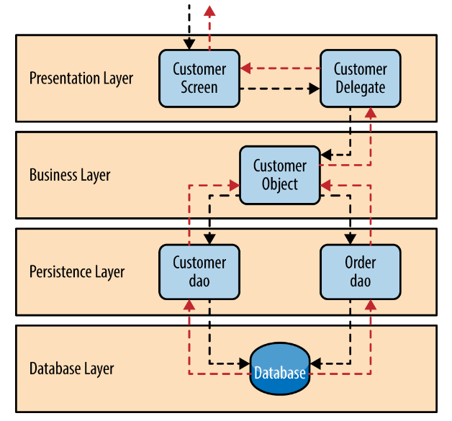

Figure : Layered Architecture Example

* Presentation Layer

Is responsible for managing the user interactions through the interface.

Ex: Include features like login, mock interview initiation, progress tracking and the dashboard.

* Business Logic Layer

Hold the main algorithms for data processing, for example AI analysis of the responses, feedback, generation. Contains services for handling questions and features of interviews as well as incorporation of AL solutions.

* Data Access Layer

Oversees all the communication with the databases. Responsible for getting and modifying entity data in the system includes users, interview sessions and feedback data.

* Database Layer

Contains all the system data such as users, mock interview and records of analysis.

Maintain the reliability related to a database that employs the standard structured data format and a strong database to query relationship (PostgreSQL).

**Advantages of Layered Architecture**

* Modularity

Every layer has its own task, which makes the system more manageable in terms of development, testing and implementation.

* Scalability

This also has flexibility as layers can be expanded or upgraded individually maintaining the integrity of the existing system.

* Reusability

Some of the functionalities such as data access of authorizations can be used by different components.

* Separation Concerns

Problem with excessively mixed functions, responsibilities, knowledge and control within layer are solved by clear and strict division of layers responsibilities

* Flexibility

It enables the addition of new technologies onto specific layers without having to reconstruct the entire system (as in updating the database or altering the front-end development framework).

**Disadvantages of Layered Architecture**

* Performance Overhead

Integration between layers might also bring about extra processing costs, more of which hamper the functionality of a system.

* Complexity

This is because strict separation of layers results in higher levels of coupling between the layers and hence more difficulties in managing dependencies.

* Initial Development Effort

Establishing the architecture and making sure each layers follows its roles may take a lot of time and

Energy.

### **6.2.1 Microservice Architecture**

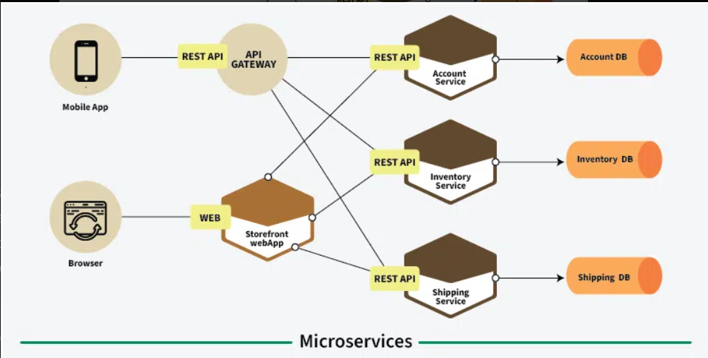

Figure : Microservice Architecture

Microservices is a style designing application as suites of independently deployable service, where each service is a microservice. Each service is dedicated to a particular business capability and can be built, deployed and managed separately. It also offers capacity for change and growth as well as compatibility with large and complex systems.

**Advantages:**

* Scalability: It is possible to scale individual services depending on the needs of the consumers.
* Flexibility: It is possible for teams to use different technologies and programming languages for each of the services.
* Faster Deployment: It means that those service individual upgrades may be deployed individually without affecting the entire application.

**Disadvantages:**

* Complexity: The need to manage multiple services means that there must be a complex mechanism for deploying, monitoring and communicating the services.
* Data management Challenges: It is not always easy to maintain data consistency across services.

Layered architecture diagram for the Interview Suit App:

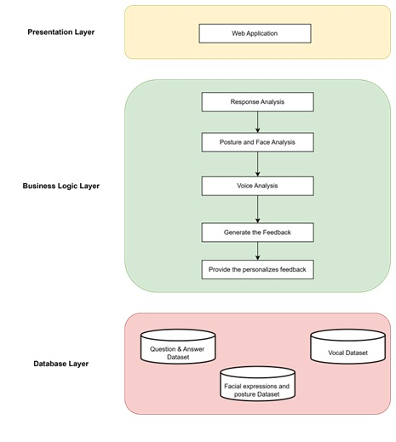

Figure : Layered architecture diagram for the Interview Suit App

## **6.3. System Design**

This section explains how elements of the Interview Suit system are organized and developed and how all features correspond to functional and non-functional requirements. It shows Layered architecture design in order to be modular, scalable and easy to maintain their system. Class Diagram, Data Flow Diagram (DFD) and Sequence Diagram are some of the diagrams that are used for representing the realization of the system.

### **6.3.1. Class Diagram/Data Flow Diagram (DFD)**

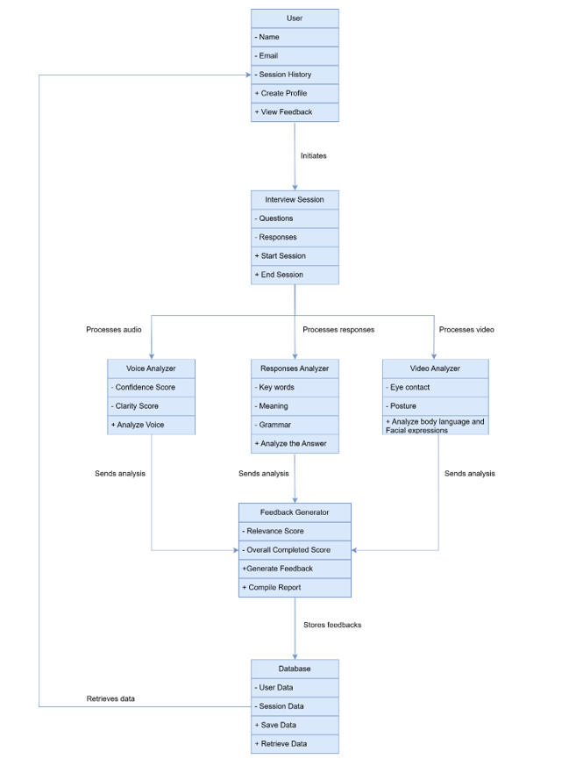

Figure : Class Diagram for The Interview Suit

### **6.3.2. Sequence Diagram**

The interaction of the parts of the Interview Suite has been depicted in the Sequence Diagram for the “Take Mock Interview” process. It describes the sequence of activities when a job seeker starts a mock interview process. The Major actors involved in the process are the Job Seekers, System Interface, the AI Engine and the Database.

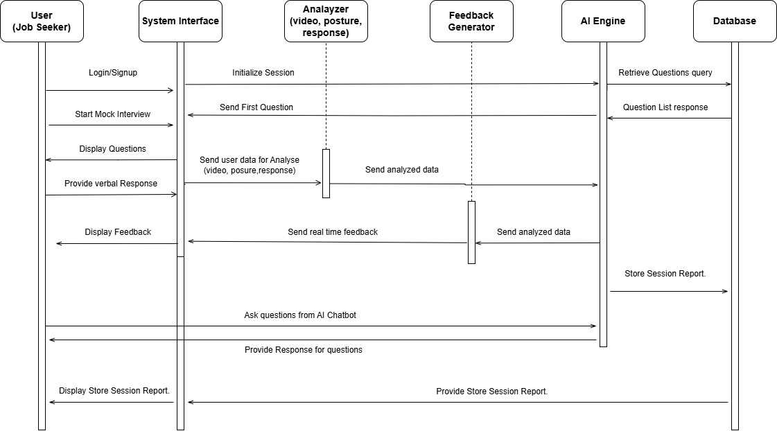

Figure : Sequence Diagram of Interview Suit

### **6.3.3.UI Design and mockups**

The UI of the Interview Suite platform was developed with Figma, an effective and shared design tool.

Here the rationale for selecting is that Figma is flexible, collaborative and easy to use. Stakeholders were

thereby able to develop and improve the high-fidelity mockups easily.

Advantages of using Figma:

* Real time Collaboration for multiple team members
* Cross platform accessible
* High fidelity prototyping
* Developer Handoff

**UI Design Approach**

The UI design is oriented on usability and convenience. Login screen, mock interview panel, dashboard and feedback were strategically developed to give clients an easy time to use the application. Interface mockups in Figma include easy navigation, clear visual layout and the use of responsive design that makes the interface look the same on any device.

With the help of Figma capabilities the Interview Suite UI was created effectively and in unison and the design of the interface is both beautiful and useful for the users.

### **6.3.4. Activity Diagram**

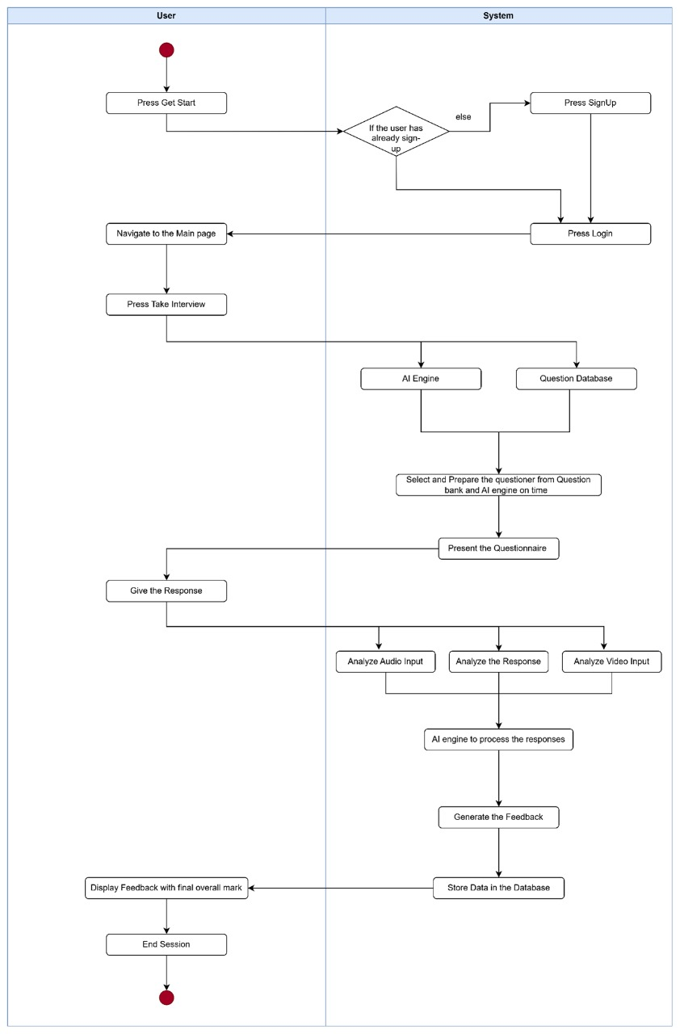

Figure : Activity Diagram

**6.4. Chapter Summary**

This chapter describes the system architecture and design of the Interview Suit platform in detail. Here discussed the Layered Architecture to keep modification, extension and other changes limited and easy to implement at different levels of the applications presentation, business, data and database levels.

The class Diagram, Data Flow Diagram (DFD), and Sequence Diagram extended the system design specifics based on entities and real data flow inside the planned system, and interaction of the components during mock interview sessions. Combined these elements create a solid framework for the actual implementation of the proposed user oriented, effective and scalable solution.

# References

1. Sommerville, I. (2016) *Software Engineering*. 10th edn. Boston: Pearson Education.
2. Pressman, R.S. and Maxim, B.R. (2020) *Software Engineering: A Practitioner's Approach*. 9th edn. New York: McGraw-Hill Education.
3. Bass, L., Clements, P. and Kazman, R. (2012) *Software Architecture in Practice*. 3rd edn. Boston: Addison-Wesley.
4. Fowler, M. (2002) *Patterns of Enterprise Application Architecture*. Boston: Addison-Wesley.
5. Dignum, V. (2019) *Responsible Artificial Intelligence: How to Develop and Use AI in a Responsible Way*. Switzerland: Springer International Publishing.
6. Raj, P. and Chatterjee, U. (2018) *Blockchain Technology and Applications*. 1st edn. Boca Raton: CRC Press.
7. Lecun, Y., Bengio, Y. and Hinton, G. (2015) 'Deep learning', *Nature*, 521(7553), pp. 436–444. DOI: 10.1038/nature14539.
8. Richards, M. (2019). *Software Architecture Patterns*. [online] O’Reilly | Safari. Available at: https://www.oreilly.com/library/view/software-architecture-patterns/9781491971437/ch01.html.
9. ‌Figma (2021). *Figma: the collaborative interface design tool.* [online] Figma. Available at: https://figma.com.
10. ‌Amini, A., Soleimany, A.P., Schwarting, W., Bhatia, S.N. and Rus, D. (2019). Uncovering and Mitigating Algorithmic Bias through Learned Latent Structure. *Proceedings of the 2019 AAAI/ACM Conference on AI, Ethics, and Society*. doi:https://doi.org/10.1145/3306618.3314243.

‌

# Appendix

*Home Page*

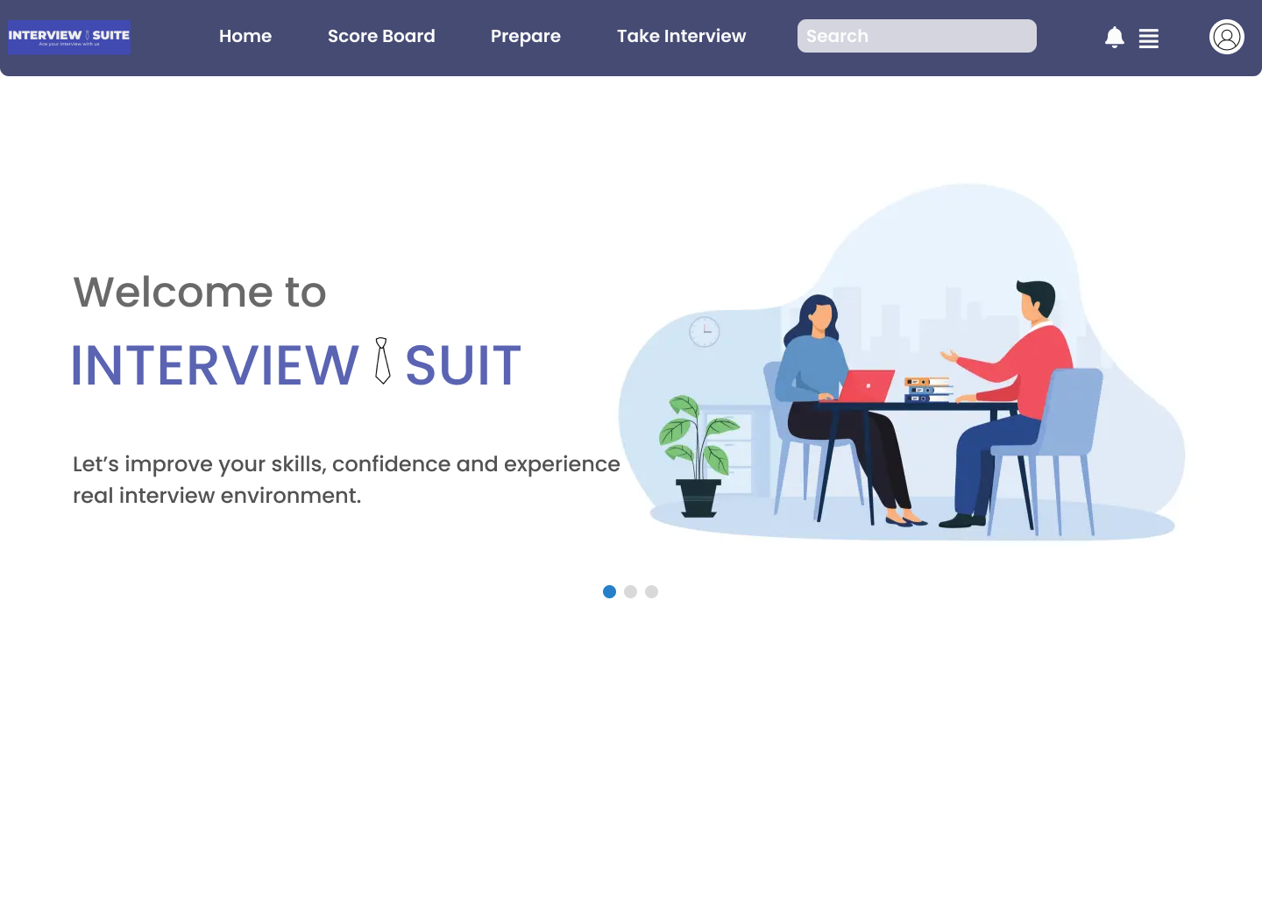

Figure : Home Page UI

*Login Page*

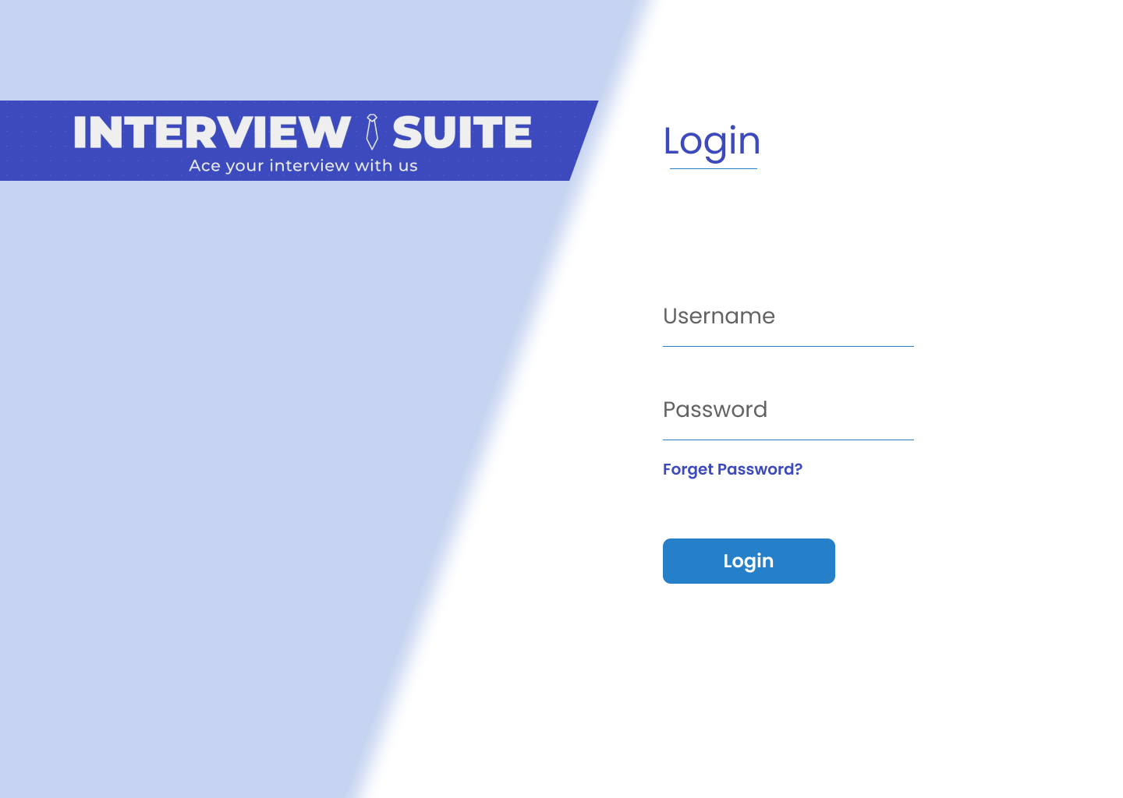

Figure : Login Page UI

*Signup Form*

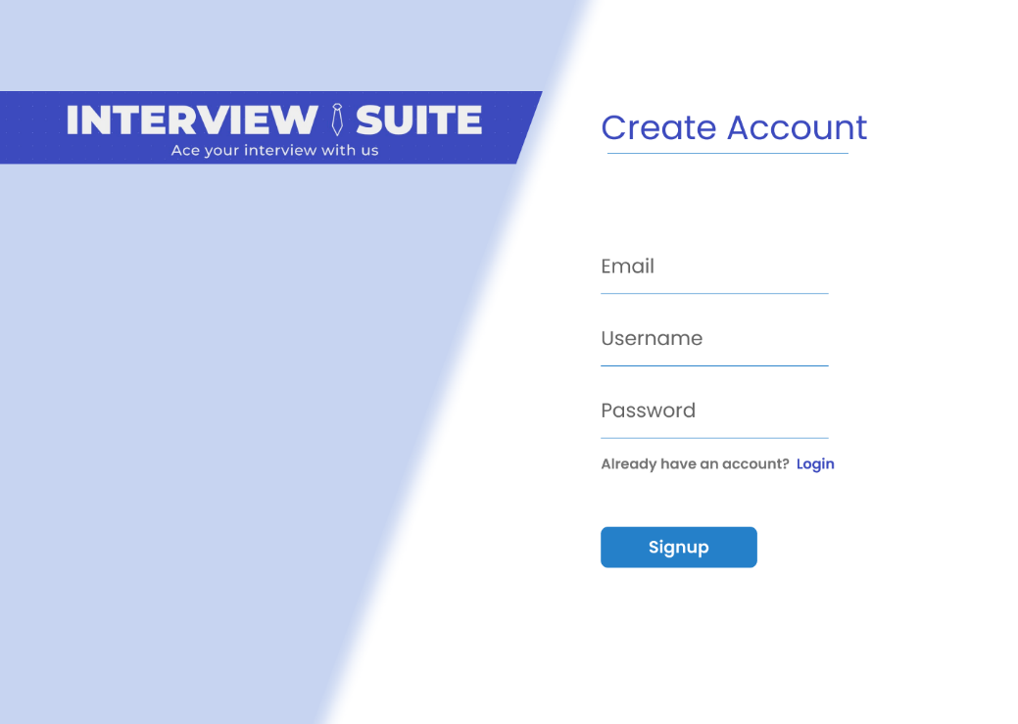

Figure : Signup Form UI

*Profile Section*

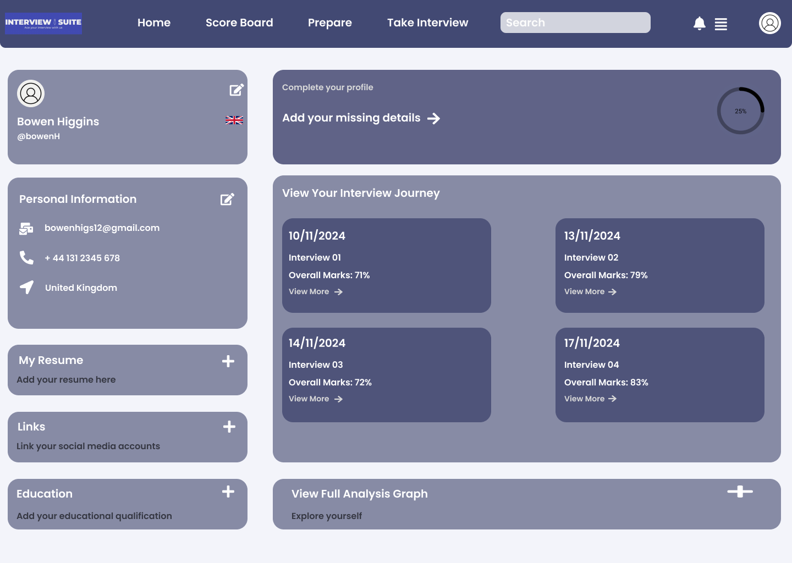

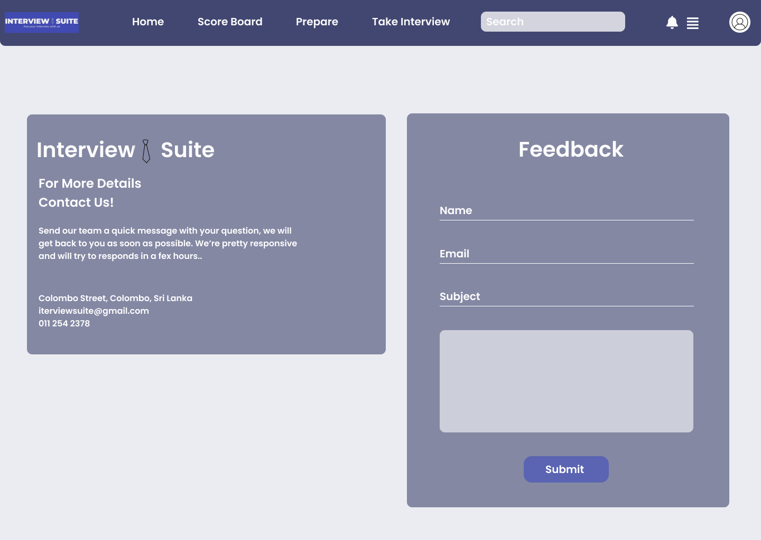

Figure : User Profile Section UI

*Sample Interview Session*

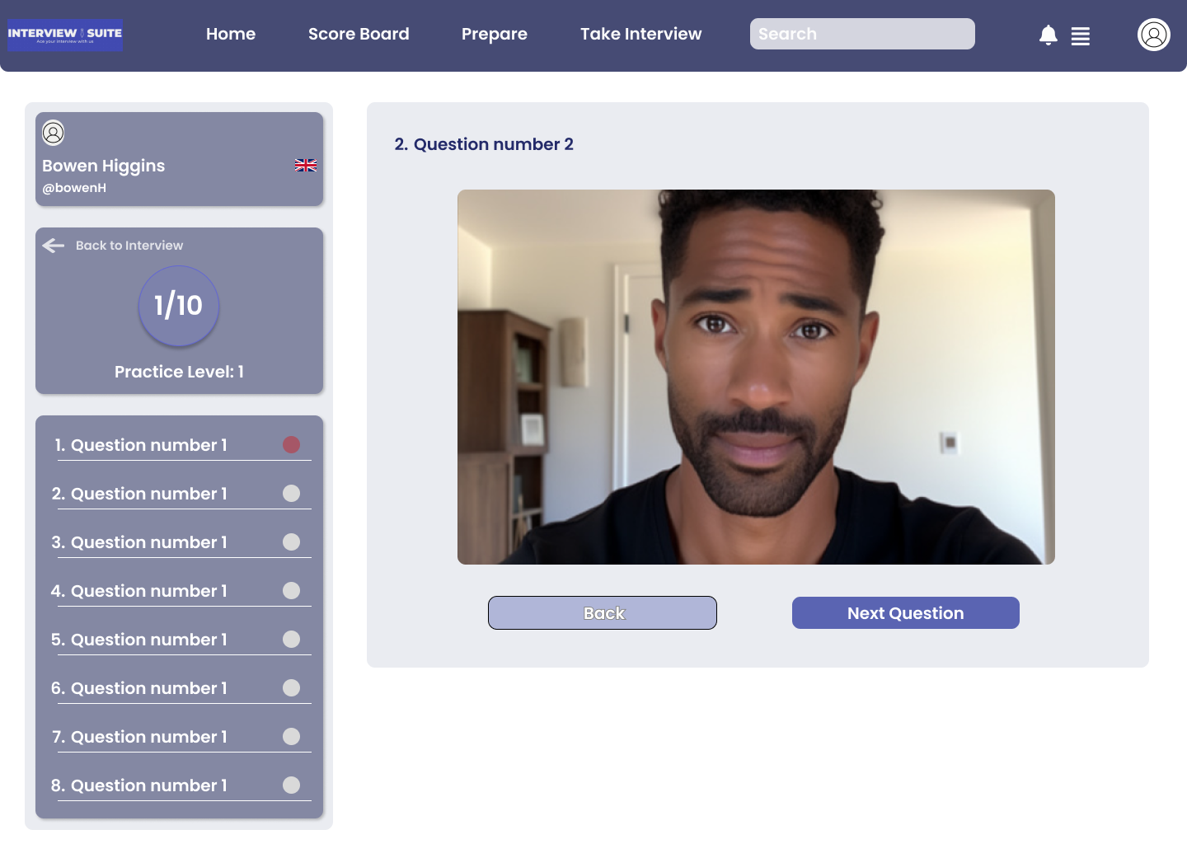

Figure : Sample Interview Session UI

*Team Member Section*

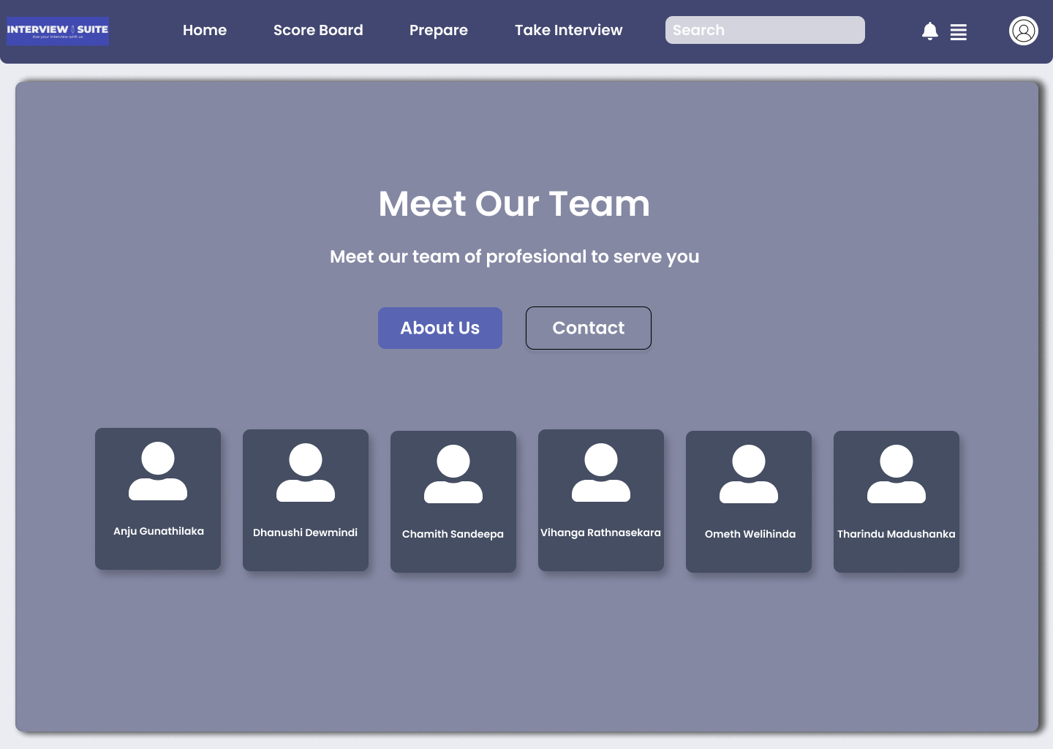

Figure : Team Member Section UI